Typescript vs interface:

Referred {

<https://www.youtube.com/watch?v=IXAT3If0pGI>

}

Similarities:

Declarations and extension and usage all are same …

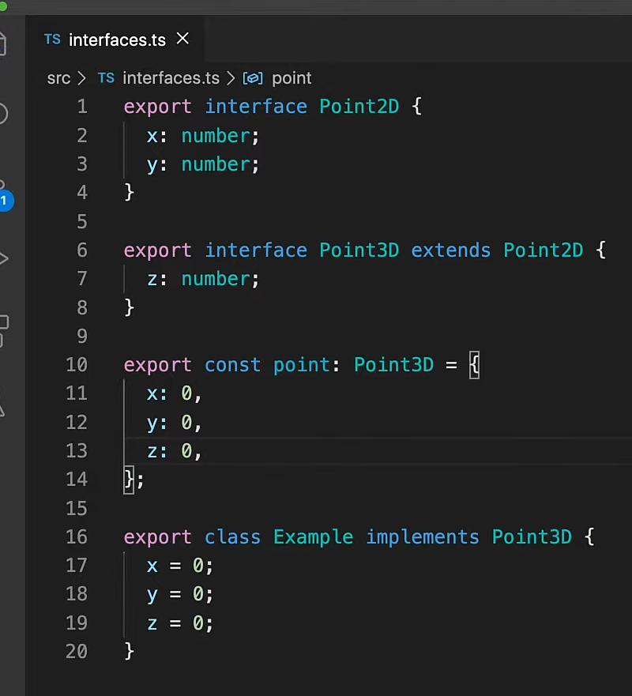

Differences:

Declaration merging in interfaces:

Express frame work have some interface, you can use the same interface name and add some other properties .. code will work like merging similar name interface props..

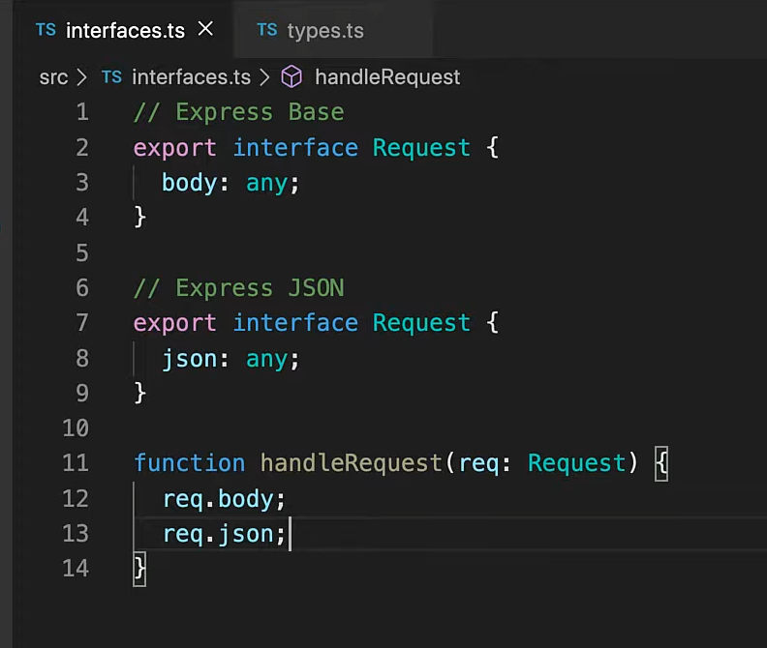

Type aliasis in type:

Anything to put in type position can be put in a type aliasis:

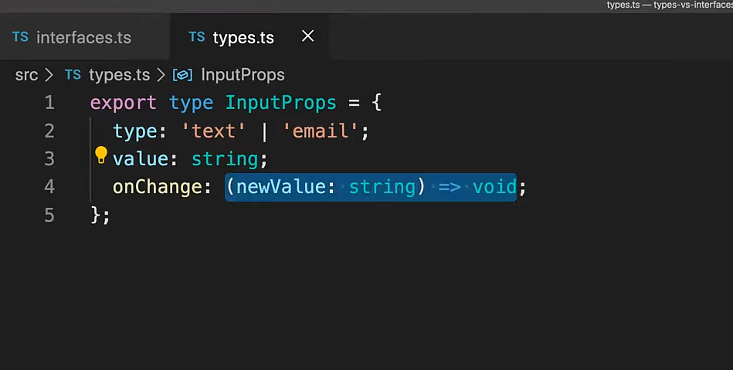

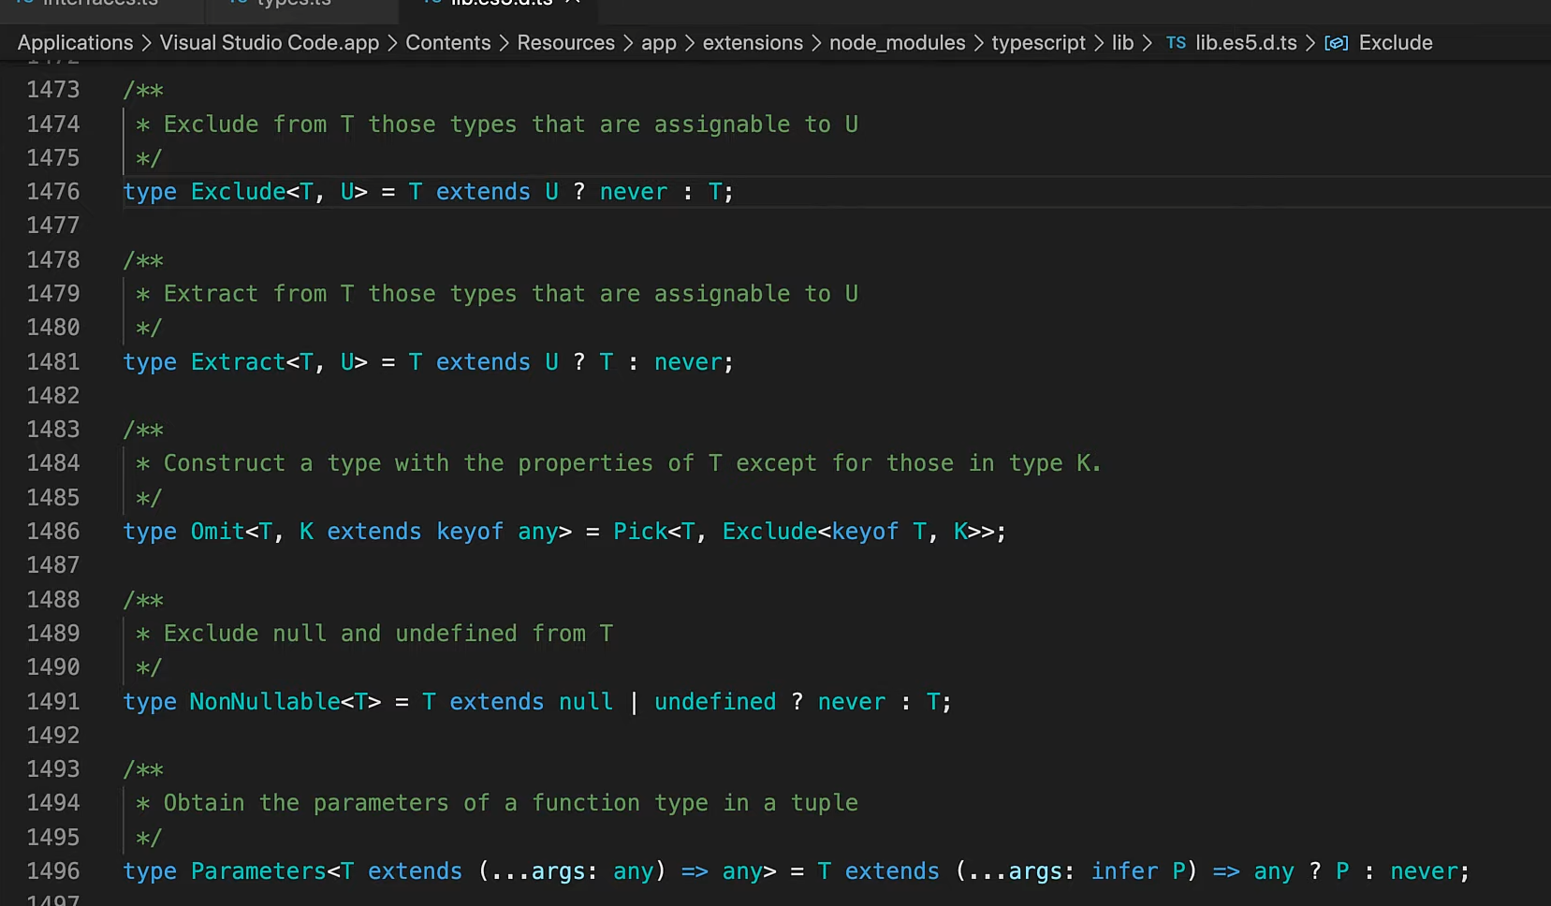

Function signature can be done with interfaces as well..

Interfaces have no way of aliasising primitive type and it don’t support union and conditional typing..

Popularity:

